**GANPAT UNIVERSITY**

**U. V. PATEL COLLEGE OF ENGINEERING**

**B.Tech CE/IT Semester IV**

**2CEIT404: Python Programming**

**Practical-7: File Operations**

1. Write a Python program to read content from a file and display the word with maximum length.

**Code:**

f1 = open("h1.txt","r")

x = f1.read()

l1 = x.split()

l = len(max(l1,key=len))

for i in l1:

    if(len(i)==l):

        print(i)

**Output:**

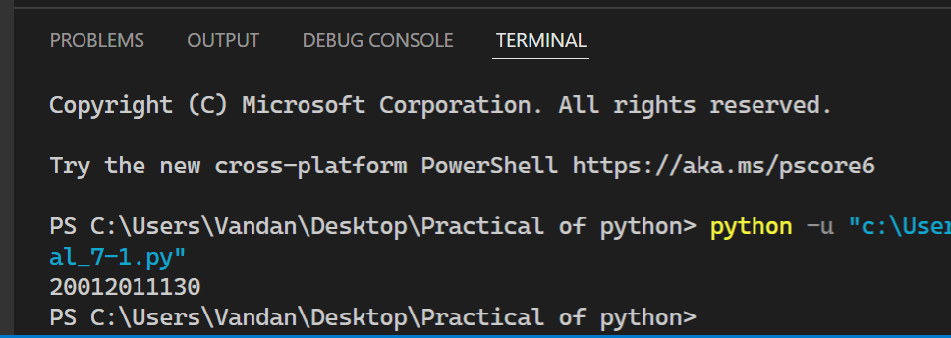

1. Write a Python program to combine each line from first file with the corresponding line in second file.

**Code:**

with open("h1.txt","r") as f1:

    with open("demo.txt","r") as f2:

        x=f1.readlines()

        y=f2.readlines()

        m=min(len(x),len(y))

for i in range(m):

 z=x[i].strip()+" "+y[i].strip()

 print(z)

f1 = open ("h1.txt","r")

f2 = open ("demo.txt","r")

for i,j in zip(f1,f2):

     print(i+j)

f1.close

f2.close

**Output:**

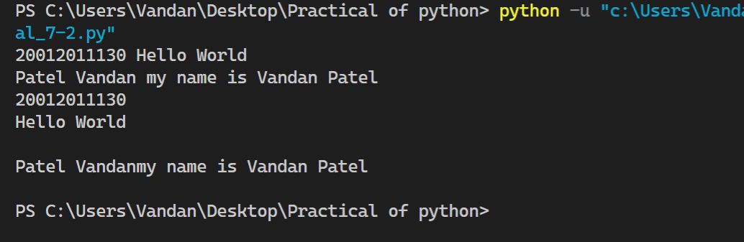

1. Write a Python program to read first n lines of a file.

Code:

*with* open ("demo.txt","r") *as* v1:

    x1 = v1.read()

    print(x1)

Output:

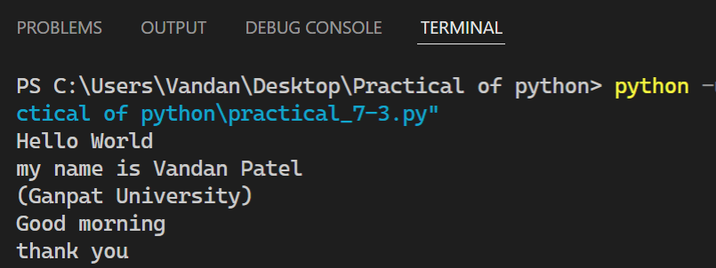

1. Write a Python program to write students information into csv file and read that details.

Code:

*import* csv

*with* open('pr7_3.csv', 'w', newline='') *as* file:

    writer = csv.writer(file)

    writer.writerow(["SN", "Name", "Branch"])

    writer.writerow([1, "Vandan Patel", "CE"])

    writer.writerow([2, "Jaydip", "CE-IT"])

    writer.writerow([3,"Nill Patel","CE"])

    writer.writerow([4,"Keval Vasoyia","CE-IT"])

    writer.writerow([5,"Vansh Patel","diploma"])

*with* open('Players.csv','w',newline= '') *as* file1:

    fieldnames = ['Players_name','Players_rating']

    writer = csv.DictWriter(file1, fieldnames=fieldnames)

    writer.writeheader()

    writer.writerow({'Players_name': 'Dhoni','Players_rating': 10})

    writer.writerow({'Players_name': 'Virat Kholi','Players_rating': 8})

    writer.writerow({'Players_name': 'Rohit Sharma','Players_rating': 9})

    writer.writerow({'Player_name': 'Hardik Pandya','Players_rating': 7})

Output:

